WARNING: MISBEHAVIOR AT EXAM TIME WILL LEAD TO SERIOUS CONSEQUENCE.
Name Student ID
School Major/Class Seat No.
( DONNOT WRITE YOUR ANSWER IN THIS AREA )
……………………………………………………Seal Line………………………………………………Seal Line………………………………………Seal Line……………………………………线………………………………………

SCUT Final Exam
Mathematical Analysis I Exam Paper B（2019-2020-1）
Notice: 1. Make sure that you have filled the form on the left side of seal line.

2. Write your answers on the exam paper.
3. This is a close-book exam.
4. The exam with full score of 100 points lasts 120 minutes.

Question No. | I | II | III | IV | Sum
Score

- Please fill the correct answers in the following blanks. (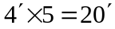)
Score

1.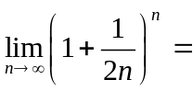 .
2. If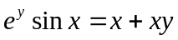, then 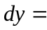 .
3. The inflection points of the curve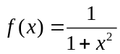are .
4. Supposeis continuous with the property that 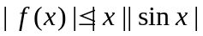for all, then 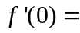 .
5. If is continuous, and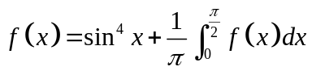, then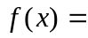 .

II．Finish the following calculations. (6-11: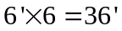)
Score

6. 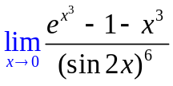.

7. 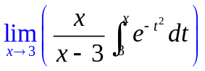

8. If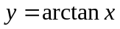, find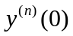.

9. Evaluate the indefinite integral 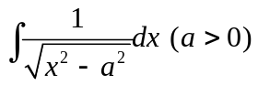

10. (a) Find the tangent to the cardioid 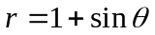at the point where 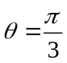.
(b) Find the length of cardioid.

III．Prove the following conclusions. (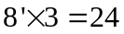 )
Score

11. Prove that 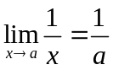() by using the 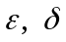 definition of limit.

12. Let 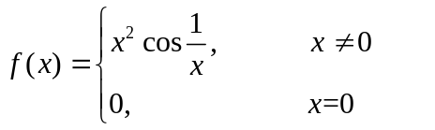.
Find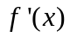. Iscontinuous at？Show your reasons.

13. If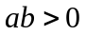. Use Cauchy’s mean value theorem to prove that there exists 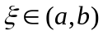 such that
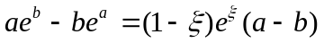

Score

IV．Finish the following questions. (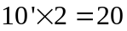 )

14. Find the volume of the solid obtained by rotating the region bounded 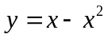and  about.

15. A sequence 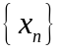is given by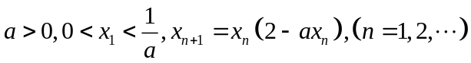. Show that 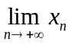exists and find it.

